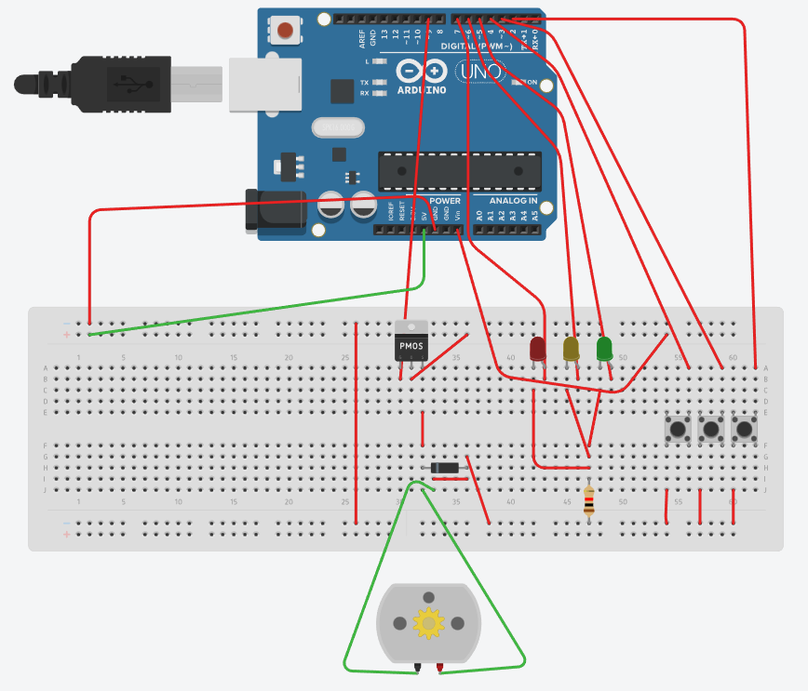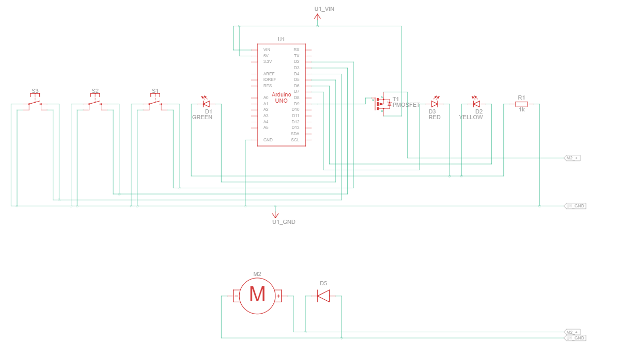

|  |  |
| --- | --- |
| bool _k2 = 0; bool _k1 = 0; void setup() { pinMode(2, INPUT_PULLUP); pinMode(4, INPUT_PULLUP); pinMode(3, INPUT_PULLUP); pinMode(6, OUTPUT); digitalWrite(6, 0); pinMode(7, OUTPUT); digitalWrite(7, 0); pinMode(5, OUTPUT); digitalWrite(5, 0); pinMode(9, OUTPUT); digitalWrite(9, 0); } void loop() { //Плата:1 _k1 = (((((!(digitalRead (2)))) || (_k1))) &&((digitalRead (4)))); _k2 = (digitalRead (3)); //Плата:2 digitalWrite (6, (((!_k2)) &&(_k1))); digitalWrite (7, (!_k1)); digitalWrite (9, ((_k1) &&(_k2))); digitalWrite (5, ((_k1) &&(_k2))); } | bool _gtv1 = 0; bool _gtv2 = 0; bool _trgs1 = 0; void setup() { pinMode(2, INPUT_PULLUP); pinMode(3, INPUT_PULLUP); pinMode(4, INPUT_PULLUP); pinMode(6, OUTPUT); digitalWrite(6, 0); pinMode(7, OUTPUT); digitalWrite(7, 0); pinMode(9, OUTPUT); digitalWrite(9, 0); pinMode(5, OUTPUT); digitalWrite(5, 0); } void loop() { //Плата:1 if(!((digitalRead (2)))) _trgs1 = 1; if(!((digitalRead (4)))) _trgs1 = 0; _gtv1 = _trgs1; _gtv2 = !((digitalRead (3))); //Плата:2 digitalWrite(7, !(_gtv1)); digitalWrite(9, ((_gtv1) && (!(_gtv2)))); digitalWrite(5, ((_gtv1) && (!(_gtv2)))); digitalWrite(6, ((_gtv2) && (_gtv1))); } |

